# 1. Introduction

## Project Background

Physical health is one of the most important areas people need to take care of. By taking care of physical health, people can thrive in life. Physical health includes a diet each individual undergoes and activities to upkeep physical aptitude. The recommended amount of aerobic activity per week is divided into two sections. Either “150 minutes” ofmoderate-intensity or “75 minutes” of vigorous “of aerobic activity per week”. Not everyone has the recommended amount of time per week. What everyone has time to do is diet effectively. Anyone can be accomplished when provided with the right tools and knowledge.

Insights from two different public organisations were included in this document. The first insight was a phrase taken from a guardian article in 2018. The phrase was “Almost 20% of deaths worldwide are attributable to an unhealthy diet”. The second insight comes from The American Dietic Association. The American Dietic Association supports suitable prepared diets. Suitable prepared diets include “total vegetarian or vegan diets”. These diets are “shown to be healthful, nutritionally adequate”. They even “may be beneficial in the prevention and treatment of certain diseases”. By knowing these insights, the aim was to develop a mobile application to assist them. The mobile application would provide them the knowledge of why they should undergo a healthy diet.

Another insight came from a result of a test carried out by a researching organisation, known as Health Education Research. Health Education Research found “ample evidence that printed, computer-tailored nutrition education” is a “effective tool”. Especially “for motivating people to change to healthier diets than general nutrition education”. The definition of printed is to “produce (books, newspapers, etc.), especially in large quantities”. This is normally accomplished “by a mechanical process involving the transfer of text or designs to paper”. The conclusion of their test implied people would be more likely to return to the computer medium than any other.

The importance of Web Applications was discovered through the work of Philip Lew, Luis Olsina and Li Zhang. “Web applications” (Web Apps) are “a combination of information content, functionality and services”. Web Apps are “becoming the most predominant form of software implementation and delivery”. Due to such trends, the same services should be provided within the mobile application. This is to ensure the mobile application follows the minimum operation standards. Following such standards would allow the development of quality software design and user interface. Completing this task would improve “the user experience as a whole”.

Overall, the following features does not exist simultaneously inside the same application: a good diet planner, tracking the diet daily and user-friendly interface for people on the go. Therefore, the decision was made to create a user-friendly mobile application for generic users. This application is known as Nutrient and Diet Manager Application (NDMA). NDMA would collaborate the mentioned features. It will also provide the user the ability to get feedback top. The tasks will be completed by enabling a logging system as part of NDMA. The other feature would be generated through a adviser system.

## Project Description

Nutrient and Diet Manager Application (NDMA) is a mobile application designed to assist the user in managing their diet. The complexity of the project is creating a User Experience (UX) that is simple and Intuitive. This is to allow a generic user to log their diet diets into the application. The development of the UX would involve creating a simplistic yet intuitive User Interface (UI). Completing that task would enable the user to get advice from the recommender system. The target audience is the generic user whom wants assistance with their diet. Part of the expected target audience profile is the ability to not necessarily consider specific details measurements. This would include a few different categories of people profile. Those whom want to improve their diet schedule to achieve a specific body shape. The office worker whom is doing 60-80 hours and needs to optimise their health. Lastly, the casual user whom just is looking for generic advice.

The two main aspects of the application are the logging system and the advisor system. The logging system provides the ability to getting logged input from the user. The advisor system would provide feedback using such logged data. Both parts of the systems would have a design of a smooth, robust, intuitive and easy UI for the user. To ensure this, the application complexity will focus on the UX as the main priority. Most applications, when dealing with information on **macronutrients** etc, expects the user to know this information themselves. This excludes an amount of people whom do not know this accurately. Therefore, the system should be able to assist the user through allowing for approximate values and visual elements to show what they look like.

The logging system will pull its data by querying a remote API system to get the associated data. The user would use such data to log their food inside the logging system. This is to minimise the user experience complexity. This data would be stored on the cloud database for remote accessibility. The advisor system uses the logged data to make appropriate suggestions to the user. Both the logging and the advisor system will take a simple UI and UX design approaches to maximise the user overall satisfactory levels.

From the beginning of the development of the application, the main business requirements will be outlined. Each iteration of prototype will be reviewed in intervals. The review will be conducted through the collaboration of people from different background. This is to ensure a diverse amount of ideas are generated for the application. This would include people from professional background to the generic user. Throughout each development stage, a prototype would be built from the feature requirements. After each prototype, the same user will be queried about the prototype to get their review. This review is used to modify, then returned to the user. This is repeated until both parties are satisfied with the efforts.

The methodologies of feature driven development, agile and prototyping will be investigated. Aspects of each methodology employed for the duration of the application development. After each prototype is completed, they would need to be tested and evaluated. After testing and evaluation, integrate into the system gracefully.

## Project Aims and Objectives

**User Requirements**

As part of the project, several people whom are potential users were spoken to for gathering requirements. A use case of three personalities were drafted up from the user requirements whom, based off their feedback, were the mutually distinct in their requirements of the application. They are as follows:

**User 1**

**Background information**

User 1 is a 22-year-old white male student. He has been vegetarian for eight years. Reasons for the initial switch was due to a dislike in taste in processed products. User 1 has both dyslexia and dyspraxia condition as disabilities. To ensure these users are not left out, the UI and UX design of NDMA must be simplified to cater to their needs.

**Expectations from the application**

User 1’s reason for using the application would ensure the diet is followed through correctly. This would involve ensuring the application understands User 1’s diet. NDMA’s understanding would be clear by filtering out the unnecessary food options by the vegetarian criteria. Such tasks should be completed in a visually aesthetic, graphical and simple user experience. The logging of his diet and inputting his personal details should be easy to complete and access. If it is forgotten during a part of the day, a notification system should remind him to continue the log process. Part of the advisor system would be a colour scheme. This would display the result of the undertaken diet in terms of how it is meeting the user’s nutritional requirements.

**Expected Scenarios:**

User 1 wants to:

* record their diet and get suggested improvements
* fully control how the application uses his personal details

**Resulted Features:**

|  |  |  |  |
| --- | --- | --- | --- |
| **User Requirements** | **Description** | **Priority** | **Scope Area** |
| Food Logging System | Allow the user to log their diet into the application through various ways | High | Mandatory |
| Nutritional Advisor System | System to advise the user based off their inputs | High | Mandatory |
| Notification System | Alert the user of the application | Medium | Out of Scope |
| Colour Scheme | A colouring scheme to alert the user how their diet is | Low | Out-of-scope |

**User 2**

**Background information**

User 2 is a 48-year-old white female. Was previously a service worker of adults with disabilities. Currently a mentor and coacher of people who work with disabilities, User 2’s experience in the area is vast.

**Expectations from the application**

User 2 has advised on several functionalities for NDMA. The functionalities overall aim would to allow two categories of people to use the application. The first are people with disabilities and the second is carers of people with disabilities. Such functionalities would cut down time on managing the dietary needs of the client. The first functionality is accessing to the camera for the scanning system. The scanning system would scan in the variety of diet choices instead of textually inputting it. Another functionality is importing a system that allows blind people to use the application. The usability of the application must be simple yet intuitive. Some optional choices are the ability to download the logged diet and display social events with people of similar interests.

**Expected Scenarios:**

User 2 wants to:

* scan the recipes into the system
* download the logged data in a report format
* see activities for people of similar interest fields
* manage and record diet to get updated good diet plan for the week
* review the for several patients diets for compliance with dietary suggestions

**Resulted Features:**

|  |  |  |  |
| --- | --- | --- | --- |
| **User Requirements** | **Description** | **Priority** | **Scope Area** |
| Logging System | Allow the user to log their diet into the application through various ways | High | Mandatory |
| Scanning System | Part of the logging system is to log by using the camera to scan in the products | Medium | Out of scope |
| Nutritional Advisor System | System to advise the user based off their inputs | High | Mandatory |
| Local Social Dietary Activities System | A system that connects people to the same activity of | Low | Out of scope |
| Feedback System with food compliance | A feedback system measuring logged data against dietary compliance for several patient patients | Medium | Out of scope |
| Download logged diet schedule | Allow the capability for the user to download the diet that has been logged. | Medium | Out of scope |
| Assistive Technology Systems | This would enable people with various disabilities to be able to use the application, such as the blind people etc. Methods, such as importing the needed system or deriving from them, would be used here | low | Out-of-scope |

**User 3**

**Background information**

User 3 is a 51-year-old white male. He has a personalised omnivore diet, which assists him in his fitness areas of interest. User 3 had been diagnosed with diabetes and interested in prevention methods for his family.

**Expectations from the application**

User 3 wants to have full control over setting his own schedule for the diet of choice. This would assist him greatly in his fitness goals. The one thing that has helped is motivational methods through challenges and awards metrics, which is fully controlled by the user. The application should provide mechanisms to describe the products he is consuming, including their meaning.

**Expected Scenarios:**

User 3 wants to

* be able to set diet schedule as per one’s interest fits
* Use and manage a metric system for interval dietary achievements
* Be educated on the food products consumed

**Resulted Technical Features in Theory:**

|  |  |  |  |
| --- | --- | --- | --- |
| **User Requirements** | **Description** | **Priority** | **Scope Area** |
| Food Logging System | Allow the user to log their diet into the application through various ways | High | Mandatory |
| Nutritional Advisor System | System to advise the user based off their inputs | High | Mandatory |
| Dietary Metric System | Enable the user to either have computer generated with a goal in mind or allow the user to create one themselves. This would be catered with the advisor system to ensure the user reaches their end goal regarding their nutritional and dietary needs. | Low | Out of Scope |
| Product Label Description UI | Provide a breakdown of how to effectively read the ingredient list of products bought from the shops using Graphical UI | Low | Out-of-scope |

**Feature Requirements**

**User Profiles**

User 1 & 3 can be categorised as User profile 1. User 2 can be categorised as User profile two. The difference between User 1 and 3 is User 1 is undergoing a vegetarian diet, where user 3 is diagnosed with diabetes. While the main feature requirements are the same for user 1 and 3, there is some differences too. With user 1, they wanted a notification system to remind them when to input their diet. They also wanted a visually aesthetic layout for the application. With user 3, they want to be able to set their own goals as part of the system. They also want to be educated on the product consumption as part of the advisor system. Where they overlap is the logging system and the advisor system as part of their feature requirements.

User profile 2 is the only one of the three where the main requirements are different for her needs. Part of user profile 2 needs which are the same is the logging system and the advisor system. The other features which are different the following: as part of the logging system, a scanning system to scan in the recipe, downloading the logged diet for review, part of the advisor system, a feedback system to input a sample diet and test against food compliance and Assistive Technology System for blind people access.

**User profile 1**

|  |  |  |  |
| --- | --- | --- | --- |
| **User Requirements** | **Description** | **Priority** | **Scope Area** |
| Food Logging System | Allow the user to log their diet into the application through various ways | High | Mandatory |
| Nutritional Advisor System | System to advise the user based off their inputs | High | Mandatory |
| Notification System | Alert the user of the application | Medium | Out of Scope |
| Dietary Metric System | A system to display the target measurements and goals set by the user | Low | Out of Scope |
| Product Label Description UI | Provide a breakdown of how to effectively read the ingredient list of products bought from the shops using Graphical UI | Low | Out-of-scope |
| Colour Scheme | A colouring scheme to alert the user how their diet is | Low | Out-of-scope |

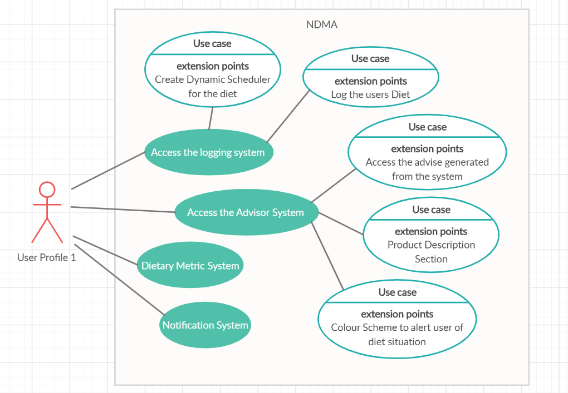**Use Case for User Profile 1**

**User Profile 2**

|  |  |  |  |
| --- | --- | --- | --- |
| **User Requirements** | **Description** | **Priority** | **Scope Area** |
| Logging System | Allow the user to log their diet into the application through various ways | High | Mandatory |
| Scanning System | Part of the logging system is to log by using the camera to scan in the products | Medium | Out of scope |
| Nutritional Advisor System | System to advise the user based off their inputs | High | Mandatory |
| Local Social Dietary Activities System | A system that connects people to the same activity of | Low | Out of scope |
| Feedback System with food compliance | A feedback system measuring logged data against dietary compliance for several patient patients | Medium | Out of scope |
| Download logged diet schedule | Allow the capability for the user to download the diet that has been logged. | Medium | Out of scope |
| Assistive Technology Systems | This would enable people with various disabilities to be able to use the application, such as the blind people etc. Methods, such as importing the needed system or deriving from them, would be used here | low | Out-of-scope |

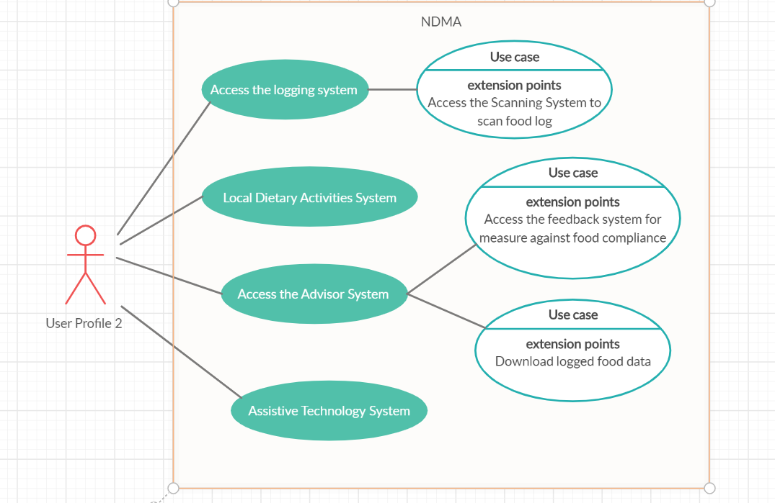**Use Case for User Profile 2**

**Other Feature Requirements:**

Some other feature requirements came up as the design process was continued to be drafted up, which would assist the users in the application overall. They were also approved by all three potential users.

|  |  |  |  |
| --- | --- | --- | --- |
| **User Requirements** | **Description** | **Priority** | **Scope Area** |
| Simple, intuitive Graphical UI | Simple UI to allow the user to log their diet into the application, using buttons and Imagery as opposed to heavy textual information.  This would resort to the user using a search bar to filter out the specific dish they had (such as pepperoni pizza as example).  Once this has been selected, the user would view the default options of food and ingredients are used before having the option to accept, accept and modify or return to search. This would allow the user to input either homemade dishes or take-aways. | High | Mandatory |
| Optimal UI / UX Experience of the advisor system | Use graphs and imagery to assist in advising the user | Medium | Out of Scope |
| Display Trends Analysis | Display the user their daily input and advise on what to do | High | Mandatory |
| Cater to user goals and macronutrients nutrition deficiencies | Implement different categorical solutions depending on both the goal of the user (ie lose weight) and their nutrition deficiencies (ie celiac) | High | Mandatory |
| Suggest alternatives for diet | Provide graphical solutions in areas where diet could improve | Medium | Out of Scope |
| Food Pyramid Interactive UI | Allow the user to find out key details about proven healthy diets, such as vegetarian, using an interactive food pyramid. This would incorporate a breakdown of what to eat regularly and examples of each (ie vegetables) | Low | Out-of-scope |
| Temporary storage and usage | Enable the user to access the features without the need for the internet | Low | Out-of-scope |

**Requirements Analysis**

After the gathering phase of the user requirements for NDMA, the feature requirement phase was drafted up. Following the feature requirement phase was the draft up and the business requirement phase, which is the collection of all the user features requirements. The business requirements are as follows:

|  |  |  |  |
| --- | --- | --- | --- |
| **Requirement Feature Analysis** | **Description** | **Priority** | **Scope Area** |
| Diet Logging System | Allow the user to log their diet into the application through various ways. | High | Mandatory |
| Download logged diet schedule | Allow the capability for the user to download the diet that has been logged. | Medium | Out of Scope |
| Simple, intuitive Graphical UI | Simple UI to allow the user to log their diet into the application, using buttons and Imagery as opposed to heavy textual information.  This would resort to the user using a search bar to filter out the specific dish they had (such as pepperoni pizza as example).  Once this has been selected, the user would view the default options of food and ingredients are used before having the option to accept, accept and modify or return to search. This would allow the user to input either homemade dishes or take-aways.  This would incorporate the ability to set the fields from previous inputs (reusing dishes) | High | Mandatory |
| Template for diet | Allow the user to decide their daily diet as to their needs, such as breakfast, lunch and dinner or brunch, dinner and supper as examples | High | Mandatory |
| Scanner for recipe input | Using the camera to scan the barcode to get the ingredients | Medium | Out of Scope |
| Advisor / Recommender System | System to advise the user, based off their inputs, what the user are eating and how it impacts their body | High | Mandatory |
| Optimal UI / UX Experience of the advisor system | Use graphs and imagery to assist in advising the user | Medium | Out of Scope |
| Display Trends Analysis | Display the user their daily input and advise on what to do | High | Mandatory |
| Cater to user goals and macronutrients nutrition deficiencies | Implement different categorical solutions depending on both the goal of the user (ie lose weight) and their nutrition deficiencies (ie celiac) | High | Mandatory |
| Suggest alternatives for diet | Provide graphical solutions in areas where diet could improve | Medium | Out of Scope |
| Colour Scheme | A colouring scheme to alert the user how their diet is | Low | Out of Scope |
| Notification / Alert System | Notify the user to use the application, whether it is to log their breakfast or to check their dietary analysis | Medium | Out of Scope |
| Product Label Description UI | Provide a breakdown of how to effectively read the ingredient list of products bought from the shops using Graphical UI | Low | Out of Scope |
| Food Pyramid Interactive UI | Allow the user to find out key details about proven healthy diets, such as vegetarian, using an interactive food pyramid. This would incorporate a breakdown of what to eat regularly and examples of each (ie vegetables) | Low | Out of Scope |
| Disclaimer within application | Ensure the user understands the application has not been reviewed for ethical standards and therefore cannot be taken seriously | High | Mandatory |
| Temporary storage and usage | Enable the user to access the features without the need for the internet | Low | Out of Scope |
| Dietary Metric System | Enable the user to either have computer generated with a goal in mind or allow the user to create one themselves. This would be catered with the advisor system to ensure the user reaches their end goal regarding their nutritional and dietary needs. | Low | Out of Scope |
| Assistive Technology Systems | This would enable people with various disabilities to be able to use the application, such as the blind people etc. Methods, such as importing the needed system or deriving from them, would be used here | low | Out of Scope |

The given timeframe for completion of the application NDMA is dated between the 16th September to 2nd April. All the requirements within the green section were known immediately out of the scope within the given timeframe. The yellow section was known to be optional choices at the start if there was time at the end. It was discovered during the research and development stage it was not feasible to include them. The red section was the main requirements that needed to be developed as within the given scope.

## Project Scope

Part of the project, during initial stage of the application drafts, which were considered as related to the project, were the following: An Alert System, Web Application System, other mobile technologies applications, the logic to track micronutrients as part of the system and a Predictive Analysis System.

The Alert System is consider related to the project as such system could be used to further assist its users. This would be by letting the user providing permissions to set up the intervals of time for the system to work with. Once setup, the user can always leave the application and return at a different type to continue logging their food schedule.

Micronutrients are like Macronutrients in terms of their importance in the diet. The only difference is they are needed to be consumed in small amounts. With a quick overview, there are at least 30+ micronutrients and would require massive logic to capture the details for optimisation.

Predictive Analysis is related to the project due to the application needs to work with data. The way it would work is taking in the data from the user and making a predication on the potential outcome. The Web Application System relates to the project as it could create a desktop web version of the application. This would enable NDMA to reach even more users around the globe whom have access to the internet.

## Thesis Roadmap

**Chapter 2 – Literature review**

The mobile applications in question came from the realm of nutrition and dietary needs. Usability methods and evaluation tools for both mobile performance and usability due to the complexity of NDMA is the user interface. Different solutions from industry were investigated to obtain key knowledge about previous attempts to solve the user requirements, such as the different types of technology applicable to domain area, other useful strategies or research relating to the application’s developers aim. Once such investigation were explored, an critic of the area which they could improve on combined with the decisions on the appropriate technologies and steps to take would be documented too.

**Chapter 3 – Experiment Design**

This chapter provides the insight into the abstract layers of the application NDMA and the routes to its development. This includes an overview of the technology researched in chapter two will be used in NDMA’s development. The technology would be evaluated against the business and technical requirements drawn up previously. The overview includes specifications sourced from NDMAs architecture to the full stack development and the chosen methodology suited to NDMA’s needs.

**Chapter 4 – Experiment Development**

The description of how the system design choices were implemented as part of the prototyping process combined with some unexpected encounters that were met.

**Chapter 5 - Evaluation**

The draft of decision taking that involves the draft up of key ideas and plans to ensure the application behave as we design it to do.

**Chapter 6 - Conclusions and Future Work**

A discussion of areas where it could possibly go wrong with the application and other possible work which could be implemented outside the current scope of the application lifecycle.